Welcome Club –
Staff contact: Megan 916-937-1365
Materials
General | Masks, Clip board, snack, water, name tag, hand sanitizer, pens, pencils, markers, check-in sheet
Soccer | balls, cones, nets
Head drawing | paper plate, markers
posters | Packing paper, markers
Airplanes | Paper strips, sticky dots

Objective
Students will be able to describe examples of integrity

Welcome Students – 10 minutes
*Boys and girls will check-in at separate classrooms.

- 1 Coach instructs students to line up outside and takes attendance. Be prepared to add new students to the roster. Ask the new student their first name, last name, grade and teacher’s name (if they do not know their teacher’s name that’s ok but the first 3 are a must).
- Remaining Coaches unstack chairs and prep group tables. We will be passing out snacks as students walk in, direct them to their table, etc. Once snacks have been passed out, please put the remaining snacks away for the day. (“Extra” snacks tend to be a distraction to students when left out and available.)
Prompt Questions: Use the questions below to start conversation.
Do you remember what Perseverance means? (keep trying even when it is hard) What did your do that was had this week?
________________________________________________________________________________________________
Welcome: Lead Coach
1st “Welcome to Welcome Club! Today we have a really fun day planned for you! first we need to go over our Welcome Club Agreements! (Use “Four Squares of Treatment” to go over how we treat each other, etc. and transition into next section).
2nd Today we are going to talk about Integrity. Who know what integrity means? Integrity means “Doing the right thing when no one is looking”

Integrity all
3rd It is time to clean up our snack! First table with clean desks and quiet arms get to go outside first!
Materials: name tags, sign in sheet, pens

game –Soccer 20 minutes
Take students outside and have them practice dribbling and weaving around cones.

Materials: balls, cones, nets

Activity: head drawing– 10 minutes
Lead Coach: explain how to play the game. Do one demo example with the coaches.
- We are going to play a silly game. Do you think you can draw a picture without looking? I am going to have my coaches put a paper plate on their head and try to draw a house. (wait for coaches to finish) Let’s see how did the coaches do? Wow that is a silly picture! Are you ready to play with your coaches?

Directions: using a paper plate, students will attempt to draw a figure without looking. Place paper plate on head and draw item described by coaches.

Example: teacher, house, car, American flag, flowers, cat, person, heart, soccer ball....

Materials: paper plate, markers

Activity: integrity posters– 20 minutes
Students are making integrity posters on how they can show integrity in different places.

Today we are talking about Integrity. Who know what integrity means? Integrity means “Doing the right thing when no one is looking”

LEAD Coach: What are some ways that you can show integrity? Good job. We are going to build an integrity banner. I have some paper for each table. I want you to draw picture or write how you can show integrity in different places.

Places: classroom, home, park, store, playground, welcome Club, or apartment complex.

Raise your hand and the table that is quiet gets to come and pick their paper first.

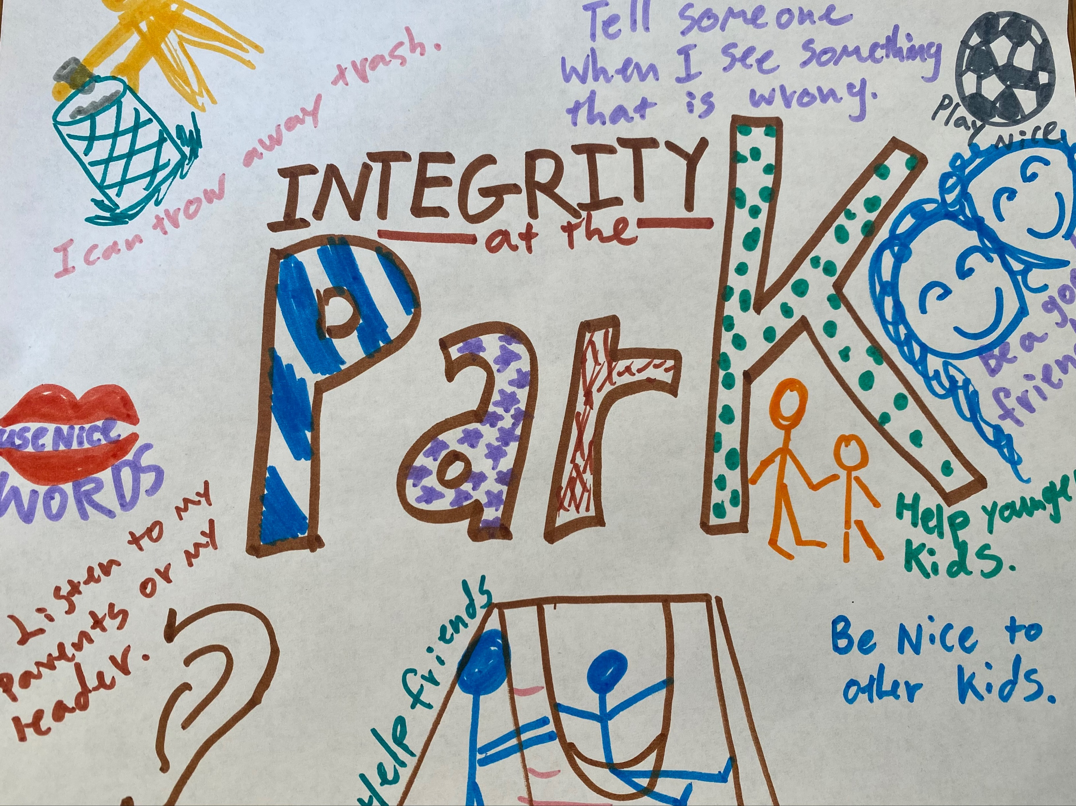

Questions while doing the posters:
- What are some things we do at_____?
- When might it be hard to do the right thing?
- Have you ever seen someone do the wrong thing?
- Have you ever done the wrong thing?
- How does it feel when you do the right thing?

After all posters are completed tape the posters together.
- Point out areas that are the same.
- Review what integrity means

Materials: paper, markers, tape

Craft/Activity: paper planes – # minutes
video of craft
- Students will take strip of paper and glue the two ends together with glue stick. Making a circle with a small handle like a balloon shape.
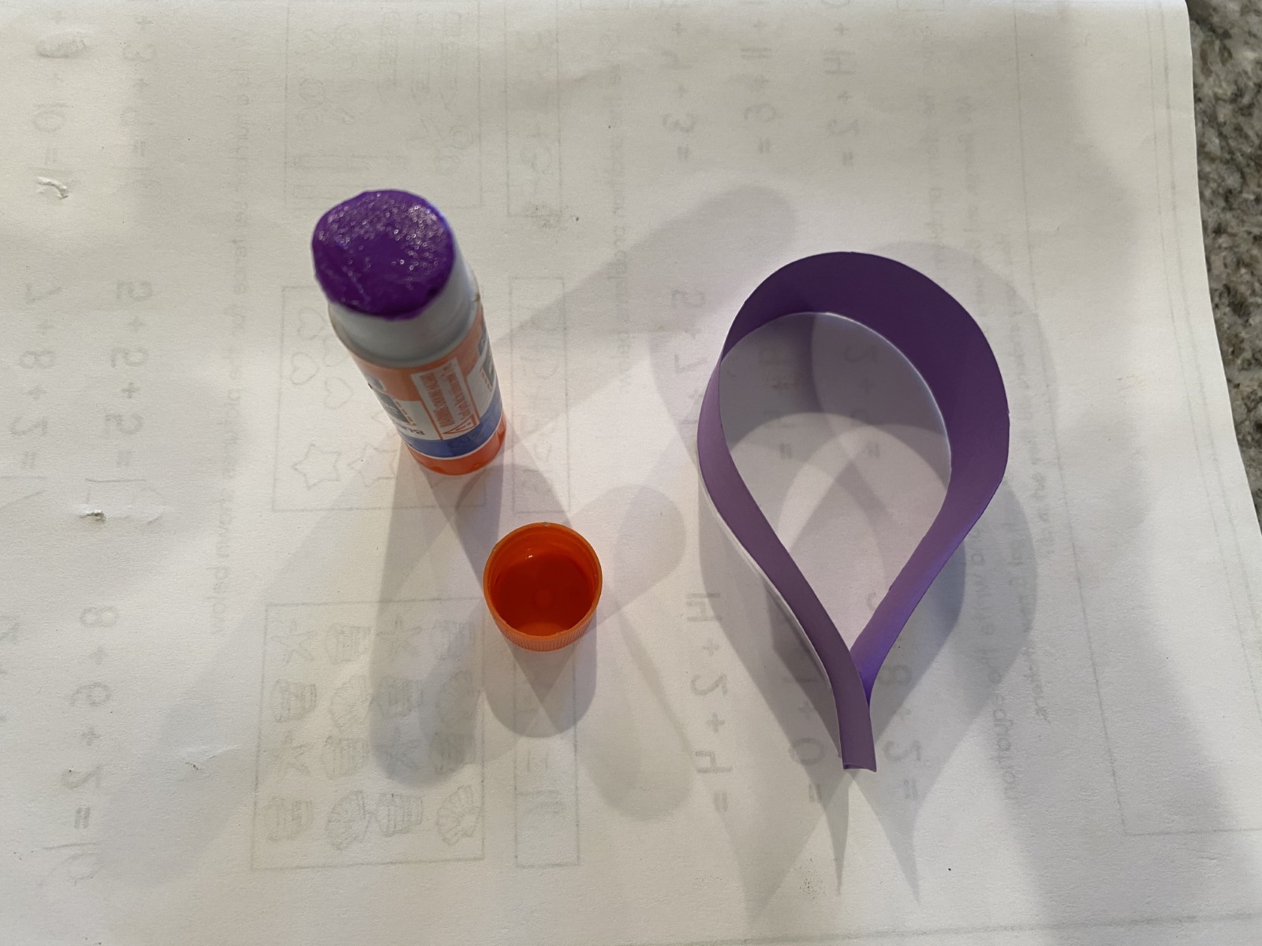
- Next, glue the top, under side middle to the middle of the top of the bottom part of the circle, making the balloon shape squished into a wing shape.
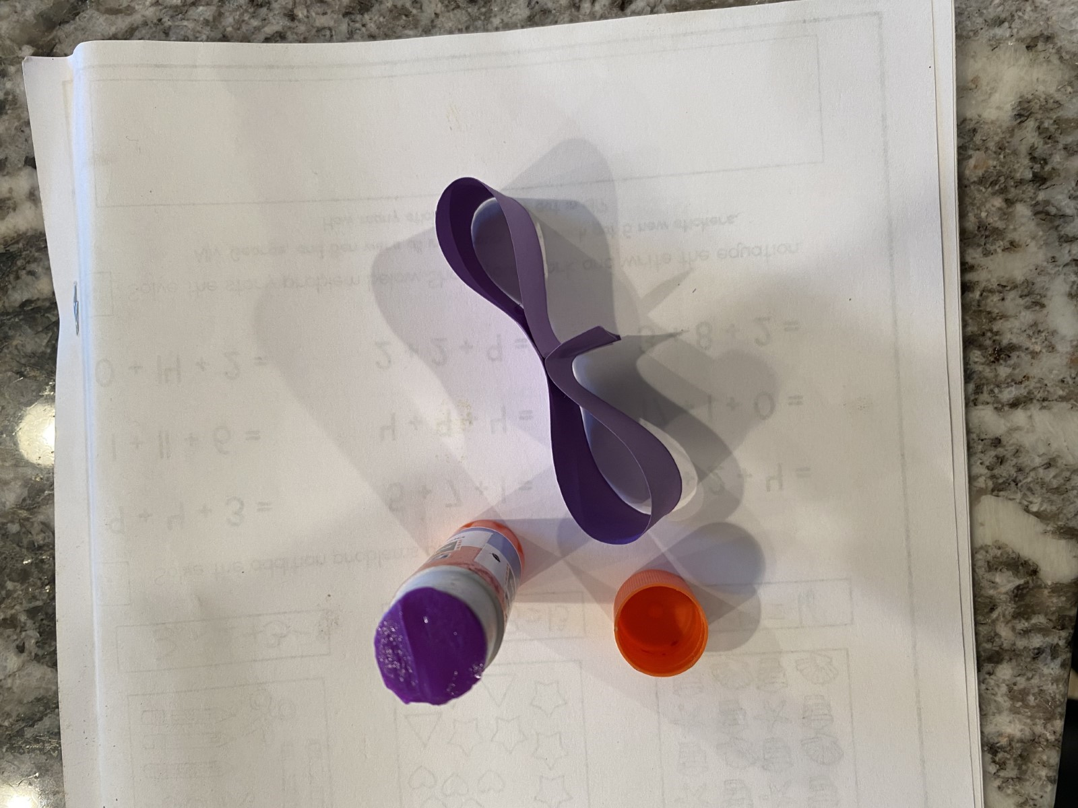
- Try out the paper flutter helicopter. Does it work? How high does it go? Does it go straight down? How does it move?
- Have an airplane race with your table. Use chalk to mark how far it flew. Remind the students about doing the right thing when no one is looking. What are some examples of this when we through the planes? (marking where our plane fell, not letting our feet cross the starting line, listening to coach)

Materials: strips of paper, glue or double sided tape, chalk

Homework – 40 minutes
We will have printed out some worksheets for the students to work on. They are categorized by grade level and subject.
Students will focus on working on their homework for the day.
Transitioning to homework time can be difficult...all coaches should work together to ensure students are moving to desks, pulling out their homework, or picking a worksheet from the folder. Pick a couple of students to sit with and assist them during homework time.

- Coaches: Give any help to students when asked. Help them work out any struggles they might have

- Tutor tips:
    - Don’t give the answer to the students - help them work it out together.
  - MATH: use visuals to help them see the problem more clearly; Help them spot key words in word problems and how to solve it
  - LITERATURE/ENGLISH: help them sound out difficult words; if they are struggling and do not know the word, give them synonyms and give them a push to right direct

Clean Up– 5 minutes
Instruct students to pick up and throw away trash before they leave.
- Pick up and throw away trash.
- Sweep floor
- Clean up WC supplies

Please fill out this Survey: https://forms.office.com/r/r1kpc21QTh

